Numerical Methods

Iterative Methods
Method | Formula | Convergence
Method | Formula | Root | Order | Guarantee
Bisection | - | Simple | 1 | ✓
Bisection | - | Multiple (Odd) | 1 | ✓
Bisection | - | Multiple (Even) | Not possible
Regula Falsi | $$x_{n+1}=b-f\left(b\right)\left(\frac{b-a}{f\left(b\right)-f\left(a\right)}\right)$$ | Simple | 1 | ✓
Regula Falsi |  | Multiple (Odd) | 1 | ✓
Regula Falsi |  | Multiple (Even) | Not possible
Secant | $$x_{n+1}=x_{n}-f\left(x_{n}\right)\left(\frac{x_{n}-x_{n-1}}{f\left(x_{n}\right)-f\left(x_{n-1}\right)}\right)$$ | Simple | $$ϕ≈1.618$$ | ✘
Secant |  | Multiple | 1 | ✘
Muller |  | Simple | 1.84 | ✘
Newton | $$x_{n+1}=x_{n}-\frac{f\left(x_{n}\right)}{f^{'}\left(x_{n}\right)}$$ | Simple | 2 | ✘
Newton |  | Multiple | 1 | ✘
Fixed Point | $$x=g(x)$$ | Improves with multiplicity. |  | ✘
Modified Newton | $$x_{n+1}=x_{n}-\frac{f\left(x_{n}\right)×f^{'}\left(x_{n}\right)}{{\left(f^{'}\left(x_{n}\right)\right)}^{2}-f\left(x_{n}\right)×f^{''}\left(x_{n}\right)}$$ | Simple | 2 | ✘
Modified Newton |  | Multiple | 2 | ✘

Muller’s Method
- Three points will be required: $\left(x_{0},f\left(x_{0}\right)\right),\left(x_{1},f\left(x_{1}\right)\right),\left(x_{2},f\left(x_{2}\right)\right)$
- Create a parabola, which is defined as: $P\left(x\right)=a{\left(x-x_{2}\right)}^{2}+b\left(x-x_{2}\right)+c$
- Substitute above points and obtain $P\left(x\right)$. This is an approximation of $f(x)$. Solve $P\left(x\right)=0$ to get the answer:
$$P\left(x\right)=a{\left(x-x_{2}\right)}^{2}+b\left(x-x_{2}\right)+c=0$$
$$x-x_{2}=\frac{-b±\sqrt{b^{2}-4ac}}{2a}$$
$$x=x_{2}+\left(\frac{-b±\sqrt{b^{2}-4ac}}{2a}\right)$$
$$x=x_{2}-\frac{2c}{b+sgn\left(b\right)×\sqrt{b^{2}-4ac}}$$

Remember:
$$d_{1}=\frac{f_{1}-f_{0}}{x_{1}-x_{0}}$$
$$d_{2}=\frac{f_{2}-f_{1}}{x_{2}-x_{1}}$$
$$a=\frac{d_{2}-d_{1}}{x_{2}-x_{0}}$$
$$b=d_{2}+a×\left(x_{2}-x_{1}\right)$$
$$c=f_{2}$$

Non-Linear System of Equations
$$f_{1}\left(x_{1},…,x_{n}\right)=0$$
$$⋮$$
$$f_{n}\left(x_{1},…x_{n}\right)=0$$
* $x_{1}$ represents a value, $x$ represents a vector, $x_{1}^{\left(k\right)}$ represents k-th iteration of $x_{1}$

Fixed Point Method
Rewrite equations as:
$$x_{1}=g_{1}\left(x\right)$$
$$⋮$$
$$x_{n}=g_{n}(x)$$
The condition is that $g_{k}(x)$ should be continuous and bounded. $g_{k}^{'}(x)$ should be bounded.
This can be shown as:
$$forall_{j=1→n}\left[\left|\frac{∂g_{j}}{∂x_{1}}\right|+…+\left|\frac{∂g_{j}}{∂x_{n}}\right|\right]≤1$$
Calculate each iteration by $x^{\left(k+1\right)}=g\left(x^{\left(k\right)}\right)$.

For convergence,
$${\left|\left|x^{\left(k\right)}-α\right|\right|}_{∞}≤\frac{K^{no. of iterations}}{1-K}×{\left|\left|x^{\left(1\right)}-x^{\left(0\right)}\right|\right|}_{∞}$$
Where:
$$n×\left|\frac{∂g_{i}}{∂x_{j}}\left(x\right)\right|≤K<1$$

Error Calculation (NPTEL)
Error vector = $E_{j}^{\left(k+1\right)}=\left|x_{j}^{\left(k+1\right)}-x_{j}^{\left(k\right)}\right|$. The stopping condition is $\max_{j}\left\{E_{j}^{\left(k+1\right)}\right\}<ϵ$. This can also be written as ${\left|\left|E^{\left(k+1\right)}\right|\right|}_{∞}={\left|\left|x^{\left(k+1\right)}-x^{\left(k\right)}\right|\right|}_{∞}<ϵ$.
$$E^{\left(k+1\right)}=g^{'}\left(i\right)E^{\left(k\right)}$$
The Taylor series expansion of $g_{1}^{'}\left(x\right)$ is:
$$g_{1}^{'}\left(x\right)=g_{1}\left(x^{\left(k\right)}\right)+{\left[\frac{∂g_{1}}{∂x_{1}}\right]}_{x^{\left(k\right)}}\left(x_{1}-x_{1}^{\left(k\right)}\right)+…+{\left[\frac{∂g_{n}}{∂x_{n}}\right]}_{x^{\left(k\right)}}\left(x_{n}-x_{n}^{\left(k\right)}\right)$$

Newton’s Method
For a collection of equations $f\left(x\right)=0$, the Taylor series expansion is
$$f_{j}\left(x\right)≈f_{j}\left(x^{\left(i\right)}\right)+{\left[\frac{∂f_{j}}{∂x_{1}}\right]}_{x^{\left(i\right)}}\left(x_{1}-x_{1}^{\left(i\right)}\right)+…+{\left[\frac{∂f_{j}}{∂x_{n}}\right]}_{x^{\left(i\right)}}\left(x_{n}-x_{n}^{\left(i\right)}\right)=0$$
Hence,
$$-f_{j}\left(x^{\left(i\right)}\right)={\left[\frac{∂f_{j}}{∂x_{1}}\right]}_{x^{\left(i\right)}}\left(x_{1}-x_{1}^{\left(i\right)}\right)+…+{\left[\frac{∂f_{j}}{∂x_{n}}\right]}_{x^{\left(i\right)}}\left(x_{n}-x_{n}^{\left(i\right)}\right)$$Convert to vectors:
$$-f_{j}\left(x^{\left(i\right)}\right)={\left[\begin{matrix}\frac{∂f_{j}}{∂x_{1}} & … & \frac{∂f_{j}}{∂x_{n}}\end{matrix}\right]}_{x^{\left(i\right)}}\left[\begin{matrix}x_{1}-x_{1}^{\left(i\right)} \\ ⋮ \\ x_{n}-x_{n}^{\left(i\right)}\end{matrix}\right]$$
Combining this for all equations,
$$-f\left(x^{\left(i\right)}\right)=JΔx$$
Where:
$$J=\left[\begin{matrix}\frac{∂f_{1}}{∂x_{1}} & … & \frac{∂f_{1}}{∂x_{n}} \\ ⋮ & ⋱ & ⋮ \\ \frac{∂f_{n}}{∂x_{1}} & … & \frac{∂f_{n}}{∂x_{n}}\end{matrix}\right]$$
Hence,
$$Δx=-{\left[J\left(x^{\left(i\right)}\right)\right]}^{-1}f\left(x^{\left(i\right)}\right)$$
$$x^{\left(i+1\right)}=x^{\left(i\right)}-J_{x^{\left(i\right)}}^{-1}f\left(x^{\left(i\right)}\right)$$

Interpolation

Lagrange’s Interpolation
- For n+1 available data points, $P_{n}\left(x\right)=\sum_{i}^{n}{l_{i}(x)f(x_{i})}$, where $l_{i}\left(x\right)=\prod_{k=0}^{n}{\frac{x-x_{k}}{x_{i}-x_{k}}}, x_{k}≠x_{i}$.
- Interpolation error:
$$\left|E\left(x\right)\right|=\left|f\left(x\right)-P\left(x\right)\right|$$
$$\left|E\left(x\right)\right|≤\frac{f^{\left(n+1\right)}\left(x*\right)}{\left(n+1\right)!}×\left|\left(x-x_{0}\right)\left(x-x_{1}\right)…\left(x-x_{n}\right)\right|$$
$$\left|E\left(x\right)\right|≤\frac{MN}{\left(n+1\right)!}$$

Newton’s Divided Difference Interpolation
$$P_{n\left(x\right)}=f\left(x_{0}\right)+\left(x-x_{0}\right)\left(f\left[x_{0},x_{1}\right]\right)+…+\left(x-x_{0}\right)\left(x-x_{1}\right)…\left(f\left[x_{0},x_{1},…,x_{n}\right]\right)$$
$f\left[x_{0},x_{1}\right]=\frac{f_{1}-f_{0}}{x_{1}-x_{0}}$ and $f\left[x_{0},x_{1},x_{2}\right]=\frac{f\left[x_{1},x_{2}\right]-f\left[x_{0},x_{1}\right]}{x_{2}-x_{0}}$

Newton’s Forward & Backward form of Interpolation
- Used when given data points have fixed range between them, i.e. $x_{n}-x_{n-1}=h$.
- A difference table is constructed:
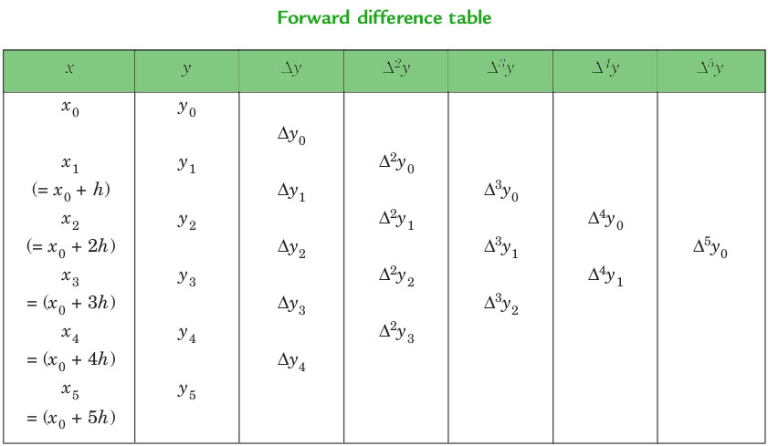
$$f\left(a+hu\right)=f\left(a\right)+\left({u \atop 1}\right)Δf\left(a\right)+\left({u \atop 2}\right)Δ^{2}f\left(a\right)+\left({u \atop 3}\right)Δ^{3}f\left(a\right)+…$$

Piecewise Interpolation
- Upper bound on linear piecewise implementation = $E\left(I\right)=\frac{Mh^{2}}{8}$
  - h is the width of the interval, and $M=\max_{x∈I}\left|f^{''}\left(x\right)\right|$
- Upper bound on linear piecewise implementation = $E\left(I\right)=\frac{Mh^{3}}{9\sqrt{3}}$
  - h is the width of the interval, and $M=\max_{x∈I}\left|f^{'''}\left(x\right)\right|$

